DWCC February Half Term Coaching Course 2023
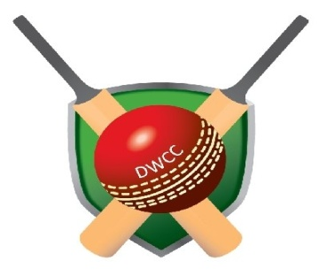
NAME: |  | DATE OF BIRTH:
ADDRESS AND POST CODE:
MOBILE NUMBER: |  | HOME TELEPHONE NUMBER:
EMAIL ADDRESS:

I WOULD LIKE MY SON / DAUGHTER TO ATTEND THE DWCC CRICKET COACHING COURSE ON THE FOLLOWING DAYS;

 | UNDER 10’S 10.00am-1.00pm  (other ages considered on request) | 10’s to 13’s .00pm-5.00pm  (other ages considered on request)
15^{h} February
16th February
17th February

I ENCLOSE A CHEQUE FOR £………………………………….. PAYABLE TO ‘DARRYL WOODS’ RETURN TO:
27 Rock Close, Carterton Oxon OX18 3BP

BACS details are Mr D Woods, Nationwide, 07 01 16, 34282688

SPECIAL HEALTH/ MEDICAL INFORMATION:

SIGNED:____________________________________________ DATE:_______________________

